Revise Menu Option1079 (CR016) to include new fields.

The fields, CRDOPNFL1F and CRDOPNFL2F, are already in ACRDMAS but not currently being used.

Display file (CR016FM) changes. CRDOPNFL1F and CRDOPNFL2F will be added to formats FMT02, FMT03, and FMT05.
Format FMT02 is used for Add and Change.
When in Add mode will need to show all options in the description field
When in Change Mode will only show the description of the selected value for the fields.
Format FMT03 is used to delete records.
This screen will display the selected values for the fields.
Format FMT05 is used to display the selected code.
This screen will display the selected values for the fields.

Program CR016 changes.
Add code to maintain the CRDOPNFL1F and CRDOPNFL2F fields.
The field name is added to a work field to in CR016 to extract/verify entered codes.

Notes: The CRDVLLST must contain the available values for these fields.
(I already added them to AFIQUA via menu option 0243 (CR016A).
To add special charges, they must exist in INSCCD file before they can be added.
Use menu option1446 (CSP321C) to maintain INSCCD.

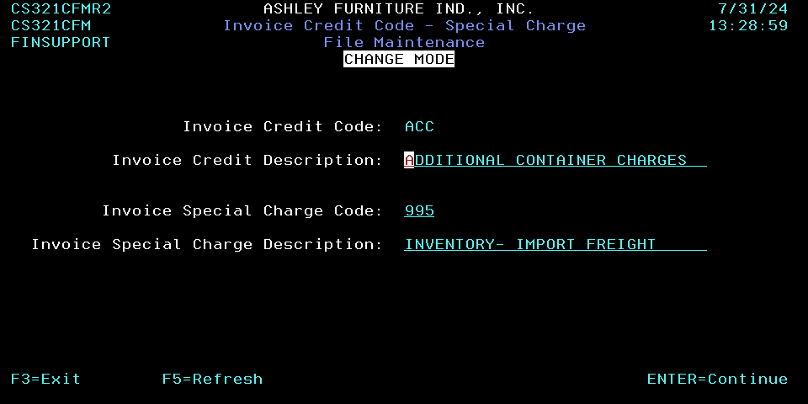

CR016 screen:
Select screen:
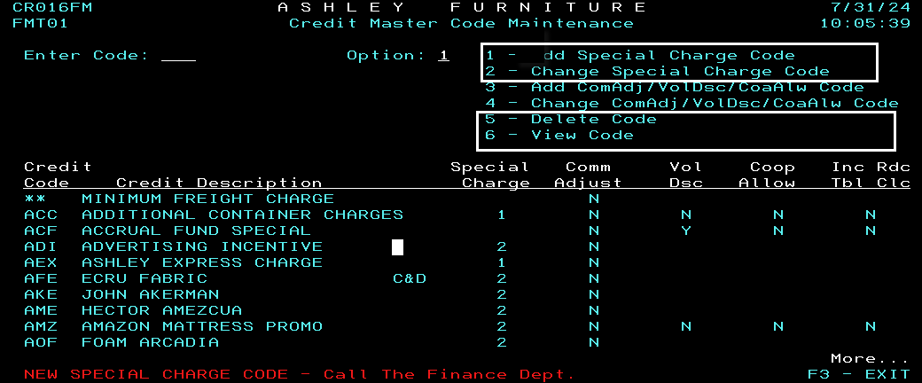

View record:
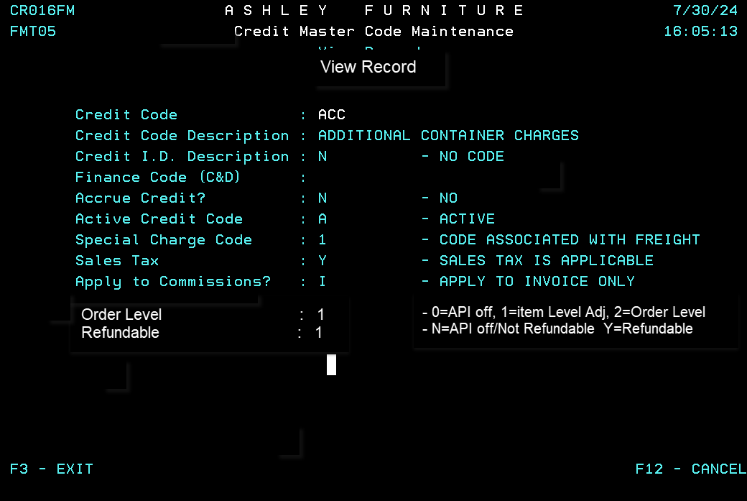
Add/Change Screen:
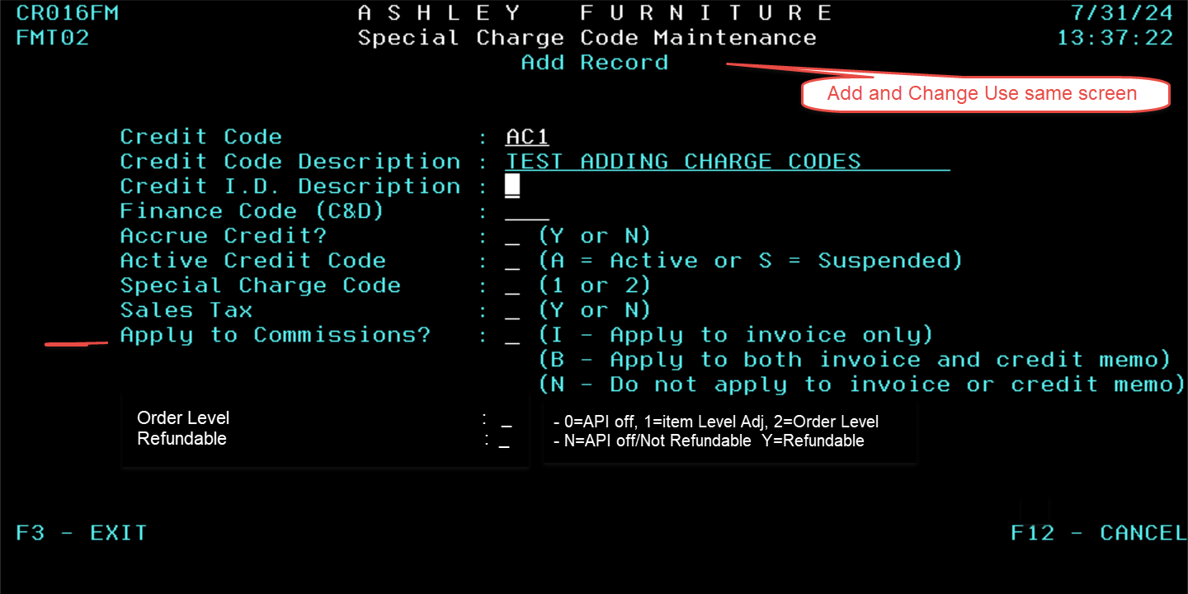
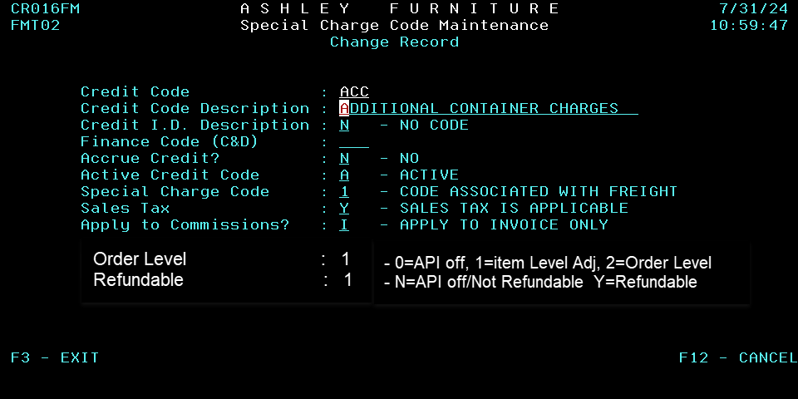

Delete Screen:


